Content for Fit.Kovai Newsletter

Monday, December 2, 2024

11:09 AM

**Design Thinking Workshop**

The workshop began with icebreakers, fostering collaboration and creativity. Participants identified key challenges, selected a critical problem using Rose-Bud-Thorn analysis, and evaluated ideas with the Importance-Difficulty Matrix. By crafting user personas, we ensured solutions were user-focused and practical. The session culminated in developing a prototype: a specialized glass for differently abled individuals.

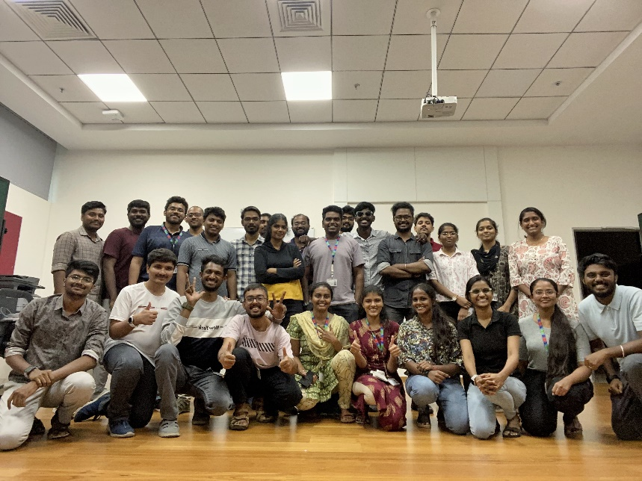

**PowerBI Workshop Series**

Every journey begins with a single step, and ours started with designing the Fit.Olympics Dashboard for FitFest. What began as a solution to a data challenge evolved into a realization – sharing knowledge is just as impactful as solving problems. This sparked the idea of a Power BI workshop series for COB associates, designed to foster learning and practical engagement.

Over five weeks, we hosted five one-hour sessions, each filled with hands-on activities covering:

1. Introduction to Power BI and Power Query Editor
2. Data Visualization and Data Modeling
3. DAX Fundamentals
4. Publishing and Collaboration

The response was incredible, with over 400 associates engaged and 250+ actively participating throughout the series. The journey concluded with a felicitation ceremony celebrating 65 dedicated associates who completed the program with flying colors!

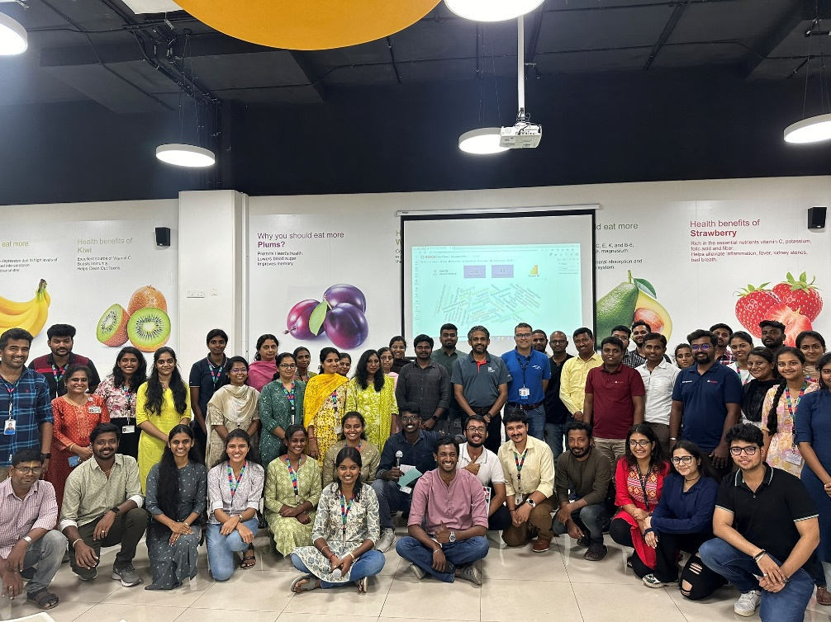

**IGNITE Island: Outbound Learning**

On 21.09.2024, we orchestrated a full-day outbound learning program inspired by the concept of IGNITE Island. Participants embarked on a creative journey through themed destinations, including a values-based treasure hunt, introspective self-portraits, and storytelling at Whispering Pines. The day also featured engaging activities like mandala art, social media editing, games at the Adventure Park, and a unique fingerprint art experience. With vibrant energy and collaborative spirit, the program concluded at the Golden Shore, leaving everyone inspired and recharged.

**IGNITE: Sharing Our Vision with Leaders**

Imagine your innovation framework reaching the CEO and securing dedicated time to present it—that dream came true for the IGNITE team. We had the honor of pitching our vision to Dattatri Salagame, whose insightful feedback reinforced our mission. Sharing IGNITE's journey with leaders like Prakash Shenoy and Philips Dayanidhi during an engaging lunch session was equally inspiring.

Key takeaways included the importance of starting and sustaining ideas, making business relatable, experimenting fearlessly, and creating excitement through gamification. With these principles closely aligned with IGNITE's ethos, we're more motivated than ever to innovate and grow!

**Connecting Flights**

The Connecting Flights event took participants on an exciting journey, starting with an overview of IGNITE and a treasure hunt leading to various "countries" (clusters). This engaging activity fostered collaboration while unveiling key outcomes like a unified platform for project insights across departments, a room locator, parking assistance, check-in/check-out mechanisms, and a gamification platform. It was a day of learning, discovery, and team spirit!

